So i tried running the app in two different devices. First one was Redmi note 3 pro (snapdragon 650,MiUi 9.0.1,Android 6) and the other one was Redmi note 5 pro (MiUi 10, Android 8)

The results in the first device were 100% failure during signup.

1) The following error was faced every single time i wanted to link my Google Account , wether as a Merchant or as a Customer.

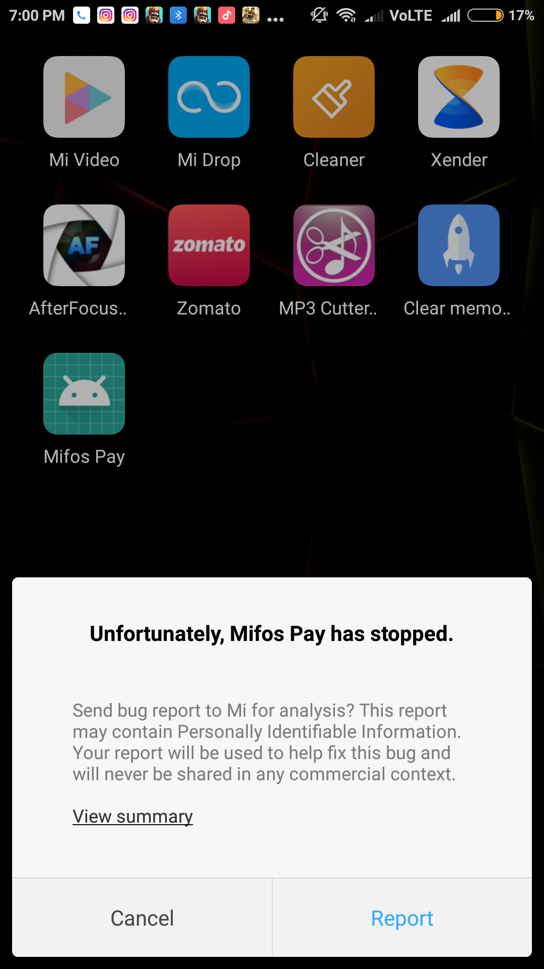

Here i would like to state that “Ease my signup using google account” was checked when it was tested.

Heres a link to screen recorded video showing the bug : https://drive.google.com/file/d/1Nsp7jnpRMEama6OcMn9ICUmkuGTGDntD/view?usp=sharing

2) Testing ont eh other device (Redmi note 5 pro), The signup page worked (“Ease my signup using google account” checked and unchecked both worked), But the refused to take mobile number as input and showed the following error :

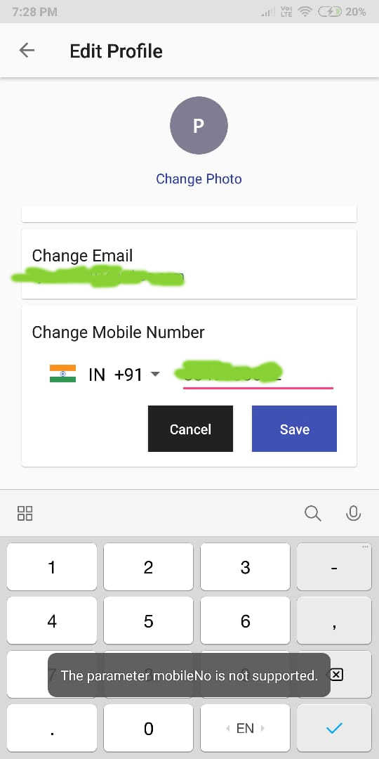
Conclusion : I was not able to successfully register any of the time due to errors faced , mentioned above.

Suggesting new features, as this is a mobile wallet,

a) Security must be number one priority – meaning an end to end encryption between the merchant and the user and no third party interference while the transfer is beign carried out.

b)As mifos is a banking app, another recommended feature from my perspective is an in built financial advisor consultant (either their contact info or from the trusted banks where user is investing)

c) Adding a virtual currency for carrying out transactions is also a goot idea to be implemented.

So the above were the features , important to include from my perspective , to make this app a daylight success in the mobile banking field.

~Regards
Prepared by :
Mr Priyansh Gupta

